Personas:

**Meet Joey:**

Joey, a 23-year-old college graduate is currently working as a software developer for a well-funded startup. He grew up in a small town in Pennsylvania where his father worked in the oil industry. While growing up, Joey dreamed of escaping his small town to see the world.

Joey hasn’t traveled much because of finances, but with his new job and carefree lifestyle, he has begun to think about spending some time visiting the countries he heard about in his youth. Joey took a few business courses in college and has a basic understanding of how exchange rates work, but he doesn’t want to put a lot of mental effort into converting currencies in his head while traveling.

Joey finds the idea of a simple currency converter that he can access from anywhere to be appealing to him, and he likes the idea of viewing currency conversions at a glance. Joey wants to be able to enter specific dollar amounts and get a conversion so that he knows how much things will cost when he is traveling.

**Meet Ralph:**

Ralph is a 33-year-old banker working for one of the large US banks. Ralph grew up with his two brothers in mid-sized Chattanooga Tennessee. Ralph was into sports growing up and while he doesn’t play organized sports anymore, he misses the competition and comradery of team sports. He has a competitive spirit and a desire to win at everything he attempts.

Ralph stays busy during the day with his work, but finds there are times when he has an opportunity to keep up with a few stocks he invests in. He has recently become interested in foreign exchange trading and would like to try his hand in the forex markets. Before he jumps into the market, he wants to study how currencies move over time. He has a strong desire to assess his ability to make money in forex trading before he jumps into the market.

Ralph likes the idea of a simple app that he can reference discretely during the day while at work. He doesn’t want to bring attention to himself, so he wants to be able to get a lot of information about the forex market quickly, at a glance, without having to click a lot of buttons, enter URLs, or click through a lot of different web pages to view forex market data.

**Meet Frank:**

Frank is a 66-year-old recent retiree. Frank lives alone with his wife in snowy Milwaukee, having raised a fine family of four children. Frank retired from a long career as a mid-level manager in the tire and rubber industry and has managed to create a decent retirement fund that allows himself and his wife to live a comfortable lifestyle.

During the long cold Milwaukee winters, Frank starts looking for activities to keep his brain occupied. Frank has always had a mind for numbers, so he seeks out ways to entertain his mathematical interests. One long-time interest Frank has nurtured is the study of historical market data. Frank has a strong belief that over the long run, the financial markets move in a predictable way and that if you study a market long enough, you can spot trends in the data. Frank has become interested in foreign currency exchange markets and he is looking for a way to test his theories about foreign exchange currency price movements.

Frank likes the idea of being able to generate time-series charts of various foreign currency exchange rates. Frank is interested in a simple tool that would allow him to generate time-series currency charts. He plans to refer to the charts often as a valuable tool in his research toolbox.

Map:

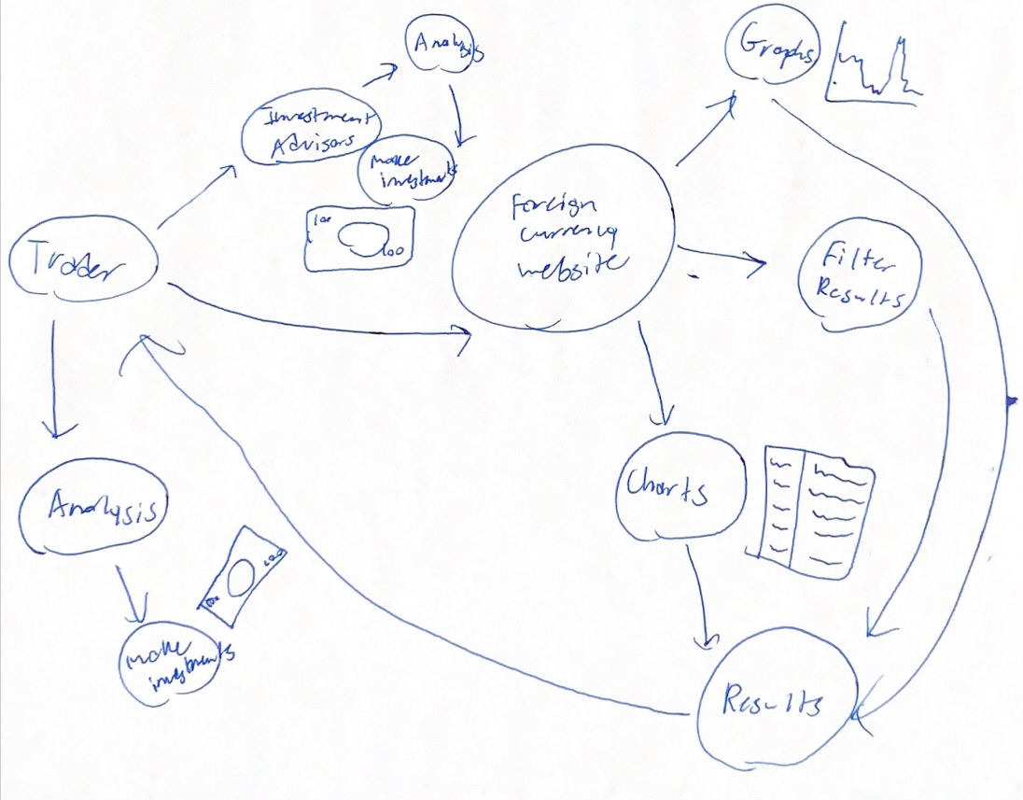

User Stories:

As a foreign currency trader, I would like to be able to search for specific currency trade exchange rates.

As a foreign currency trader, I would like to be able to organize currency trade information into charts or graphs.

As a foreign currency trader, I would like to filter results to find specific information.

Feature List:

* A database of foreign currency information to search from
* A filter system to find specific information
* A charting and graphing system to organize information into visuals
* A website that can display all of this information and graphics
* Other visuals to bring allow for more information to be displayed